**NAME:SHERALI**

**LABTASK: 12**

QUESTION 1:

PART(A)

sum=0

file=open("names.txt","r")

for line in file:

line=line[0:4]

line=line.strip("\n")

print(line)

OUTPUT:

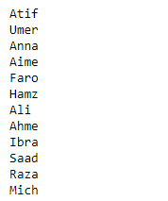

PART(B):

file=open("names.txt","r")

add=0

for i in file:

i=i.strip("\n")

add+=len(i)

print(add)

OUTPUT:



PART(C):

file=open("names.txt","r")

counter=0

add=0

for i in file:

i=i.strip("\n")

add+=len(i)

counter+=1

print("Average is",add/counter)

counter=0

first=file.readline()

a=len(first)

for i in file:

if len(i)<a:

print(i)

OUTPUT:



PART(D):

file=open("names.txt","r")

first=file.readline()

a=len(first)

for i in file:

if len(i)<a:

print(i)

OUTPUT:



PART(E):

def print_name(n):

file=open("names.txt","r")

for i in file:

if len(i)==n+1:

i=i.strip("\n")

print(i)

print_name(5)

OUTPUT:

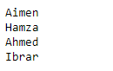

PART(F):

file1=open("names.txt","r")

file2=open("name_subject.txt","w")

for line in file1:

a=line + "programming fundamental lab, programming fundamental, English composition, calculas-1"

file2.write(a)

print(a)

file1.close()

file2.close()

OUTPUT:

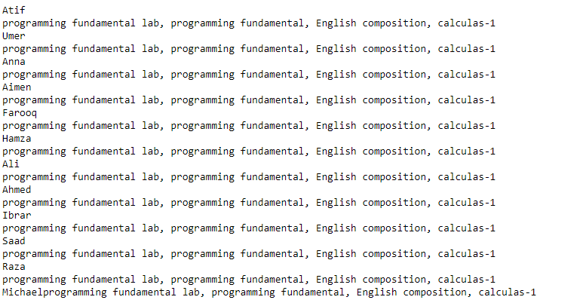

PART(G):

def search_key():

n=input("Enter name")

file=open("names.txt","r")

r=file.read()

if n in r:

print("True")

else:

print(False)

search_key()

OUTPUT:

